Ministry of Higher and Secondary Special Education of the USSR
Moscow Mining Institute
PHYSICS OF ROCKS AND PROCESSES
PUBLICATIONS
Collectionnumber55
Moscow 1967
V. A. MILYUSHENKO,A. C. Utkin
On the frequency dependence of the electrical rocks
The rocks are a combination of different rock-forming minerals. In its electrical properties may be a dielectric, and an electric cable. Under the influence of the electromagnetic field in the rock there is the total current,which consists of current conduction of free charges and the displacement current:
$\vec{j_{полн}}$ =$\vec{j_{пров}}$+$\vec{\frac{∂D}{∂t}}$ (1)
Electric displacement vector $\vec{D}$ is associated with field strength $\vec{E}$ and the polarization vector $\vec{P}$ ratio:
$\vec{D}$ = $ε_{0}\vec{E}$ + $\vec{P}$(2)
where:$ε_{0}$ - dielectric constant.
In the rock, which is a heterogeneous environment, there may be all kinds of polarization. Their total is the total polarization vector that is conveniently regarded as the sum of two components: the instantaneous and relaxation:

$\vec{P}$ = $\vec{P_{мгн}}$ +$\vec{P_{рел}}$(3)

Instantaneous polarization Rмгн is the sum of the elastic polarization of electron and ion displacement that radio frequencyvaries in proportion to the electric field vector of the instantaneous Therefore, the polarization can be written:
$\vec{P_{мгн}}$ = $ε_{0}χ_{мгн}\vec{E}$(4)
where:$χ_{мгн}$- polarizability of the elastic displacement.
The relaxation component of the total polarization vector, which is the sum of the dipole orientation,thermal, ionic, structural and electrolytic polarization lags behind the phase change of the electric field.The dependence of the relaxation time of the polarization expressed as a sum of exponentially growing functions
$\vec{P_{рел}}$= $ε_{0}\sum_{k}{χ_{{рел}_{k}}}\left(1- e^{-\frac{t}{τ_{k}}}\right)\vec{E}$ (5)
where $χ_{{рел}_{к}}$ - the polarization relaxation $τ_{k}$ -relaxation time of each type of relaxation polarization.

Thus, the total polarization vector is written as
$\vec{P}$= $ε_{0}χ_{мгн}\vec{E}+ε_{0}\vec{E}\sum_{k}{χ_{{рел}_{k}}}\left(1- e^{-\frac{t}{τ_{k}}}\right)$ (6)
For harmonically varying field $\vec{E}$ = $\vec{E_{0}}e^{iωt}$ full polarization vector can be written as:
$\vec{P}$ = $ε_{0}\vec{E}\left(χ_{мгн}+\sum{}\frac{χ_{{рел}_{k}}}{1+iwτ_{k}}\right)$(7)
Replacing in (2) the polarization vector P in terms of its value from (6) and substituting the obtained value of the electric displacement D in equation (1) yields:
$\vec{j_{полн}}$= $σ_{пров}\vec{E}$+$ε_{0}$i$ω\vec{E}$+ $ε_{0}iωχ_{мгн}\vec{E}$ +$ε_{0}$iω$\vec{E}$∑$\frac{χ_{{рел}_{k}}}{1+iωτ_{k}}$(8)
Total conductivity of the rock, which is determined on the basis of equation (7)
$σ_{полн}= σ_{пров}+ iωε_{0}+iωε_{0 }χ_{мгн}+ iωε_{0}\sum_{k}{\frac{χ_{{рел}_{k}}}{1+iωτ_{k}}}$(9)
The first term of the admittance(ohmic conduction) is created in the rock-free electric charges.The second term is the conductivity of the displacement current in a vacuum. The third and fourth termdue tothe presence of the rock polarization currents instantaneous polarization and relaxation, the last component of a complex value.Its real part
Re $\left(iωε_{0}\sum_{k}{\frac{χ_{τ_{k}}}{1+iωτ_{k}}}\right)$= $\sum_{k}{\frac{ε_{0}ω^{2}τ_{k}χ_{{рел}_{k}}}{1+{\left(ωτ_{k}\right)}^{2}}}$(10)
is the active component of the total electrical conductivity and on a par with ohmic conductivity determines the loss of electromagnetic energy that go into heating the rock.
Imaginary part
Im $\left(iωε_{0}\sum_{k}{\frac{χ_{{рел}_{k}}}{1+iωτ_{k}}}\right)$= $\sum_{k}{\frac{iωε_{0}χ_{{рел}_{k}}}{1+{\left(ωτ_{k}\right)}^{2}}}$(11)
in conjunction with the second and third terms is the reactive component of the total electrical energy losses and causes no.
Let us consider the active component of the total electric
Re$σ_{полн}= σ_{пров}+ \sum_{k}{\frac{ε_{0}ω^{2}τ_{k}χ_{{рел}_{k}}}{1+{\left(ωτ_{k}\right)}^{2}}}$ (12)
It is not only dependent on the frequency in the absence of relaxation processes.Because rocks relaxation processes occur generally depends on the conductivity of the active component of the frequency. Radio frequency$ω≪\frac{1}{τ_{k}}$value under the sum is negligible and the dependence of the total conductivity is weak.At frequencies$ω≫\frac{1}{τ_{k}}$ its value tends toalso $\frac{ε_{0}χ_{{рел}_{k}}}{τ_{k}}$and substantially independent of frequency.If the field frequency is close to $\frac{1}{τ_{k}}$,the active component of the admittance has the most vivid frequency dependence.
For some relaxation time distribution is a monotonic increase in conductance with increasing frequency, and the form of this dependence is determined by the polarizabilityx and relaxation time.The distribution of relaxation times and the magnitudeof the polarizability of certain types of polarization are poorly understood, so the theoretical calculation of the frequency dependence of the conductance is in serious trouble.For practical purposes, the frequency dependence of the real part of the complex conductivity with sufficient accuracy can be defined experimentally.
Experimental study of the electrical conductivity of rocks depending on the field frequency in a large number of works of Russian and foreign authors.Fig. 1 shows a number of frequency dependence of the resistivity of various rock obtained using various measurement methods. Despite the seemingly contradictory nature of dependence of the resistance of different rocks on the frequency, they are all in good agreement with the theoretical assumptions.
Virtually no frequency dependence of the electrical resistance of rocks according to Smith-Rose (resonant circuit), B. S. Enenshteyna (field measurement), M. I. Mikhailov (field measurements, Lecher line), and Abraham (field measurements, Lecherline) who studied the rocks and soils with high electrical conductivity.In contrast, a pronounced frequency dependence from the data ofKeller and Likastro (bridged), A.V. Veshev (kumetr), Chakravarty and Hastgira (Lecher line), A. D. Petrovsky (radio sounding), investigating the rocks with a high ohmic resistance ρ$>{10}^{3}$Om.m.
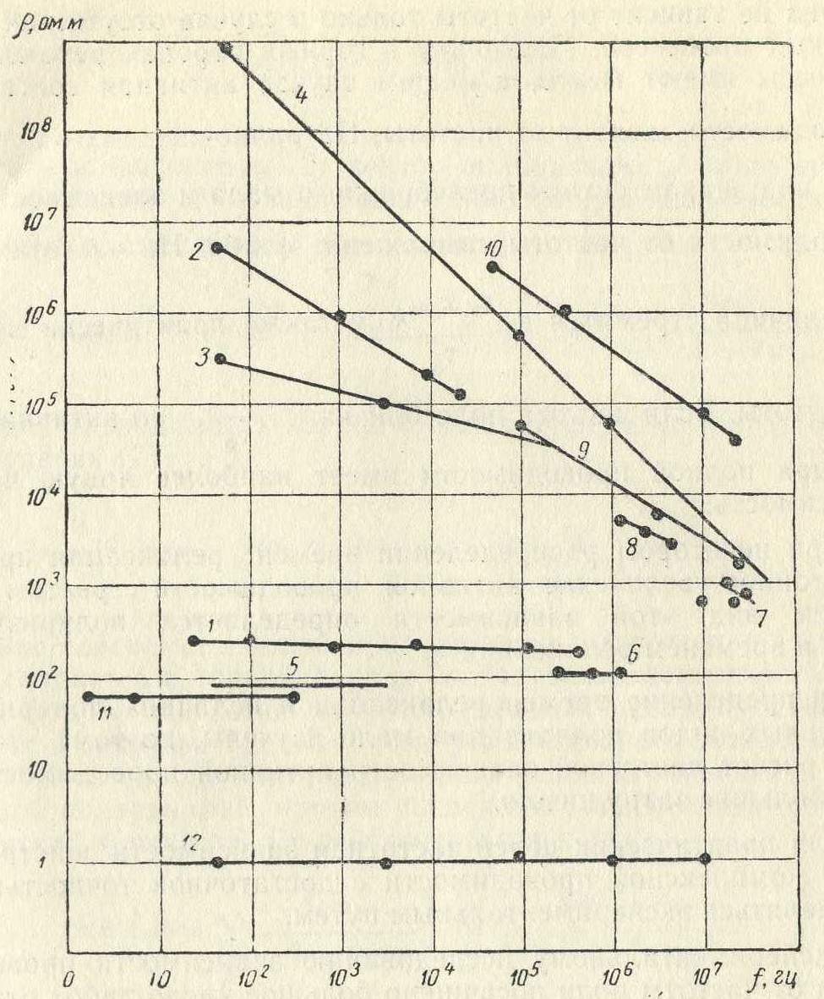
Fig. 1. The frequency dependence of the resistivity of rocks taken from:
1, 2 - M Strutt, 3, 4 - G. Keller, 5 – M.I. Mikhailov, 6 - Abraham, 7 - M. Chakravarty, S. Khastgir, 8 – A.D. Petrovsky,
9 - D. Karshinsky, 10 – A.V. Veshev, 11 – B.S. Enenshteyn, 12 - R. Smith-Rose.
Of great interest is the work of Shtrutta (bridged), who studied the rocks with a high ohmic resistance (dry river sand $ρ >{10}^{5}$ohm-meters) and soil with low resistance of ${10}^{3}$ ohm-meters.In the first case it was striking frequency dependence as soil resistance with increasing field frequency of 20,000 times decreased only by 1.5 times.
Similar dependence of the resistance of different rocks Lt. frequency obtained by us (Fig. 2) experimentally using kumetrov E9-1, E9-2 and Lecher line.In the frequency range 30 - 100 MHz applied to the compensation method of measurement(6).Forhigh-resistivity rocks (Fig. 2, curves 1 - 9) showed a strong increase in conductivity with increasing frequency electric field.These rock-through conductivity compared with the relaxation conductivity is negligible quantity.
With the increase of the share of the ohmic conductivity (Fig. 2, curves 10,11) is slower growth Re σis full.In low-resistivity rocks (curves12-14) plays the main role-through conductivity, and varies with the frequency of the active component of the polarization current is a small part of the total conductivity of rock.Therefore, the frequency dependence of the total conductivity, and hence the resistivity is practically absent.
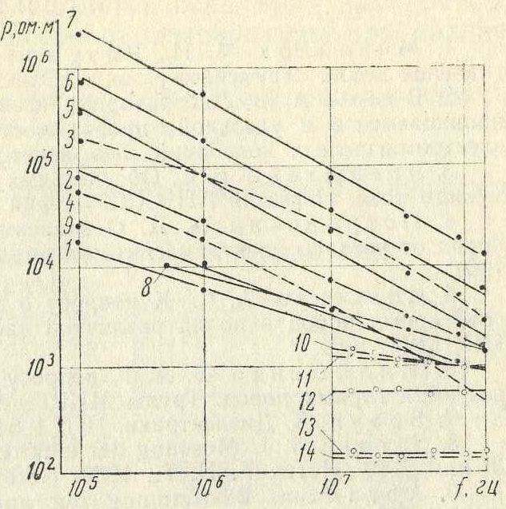
Fig. 2. The dependence of the resistance of air-dried samples of some rocks on the frequency
1, 2 - ijolites, 3, 4 - rischorrites 5 - urtite, 6, 7, 8 - apatite ore, 9 - lujaurite, 10 - limestone, 11 - coal, 12 - sandstone,
13 - sandy shale, 14 - clay slate.
Conclusions
- The real part of the complex conductivity of the rock is caused by two factors: the transfer of the electric field of the free electric charges and relaxation processes
Re$σ_{полн}= σ_{пров}+ \sum_{k}{\frac{ε_{0}ω^{2}τ_{k}χ_{{рел}_{k}}}{1+{\left(ωτ_{k}\right)}^{2}}}$
- The conductivity of the rock is a function of the frequency of the electric field. The criteria for determining the nature of the frequency dependence of theelectrical conductivity of rocks is the second term.
$$\sum_{κ}{\frac{ε_{0}ω^{2}τ_{κ}χ_{{рел}_{k}}}{1+{\left(ωτ_{k}\right)}^{2}}}$$
- The relative change in the electrical conductivity of the rock with a frequency dependent on the proportion of terms in (11).For low-resistivity rocks ratio is in favor of the ohmic conductivity as a result of the frequency dependence of the electrical conductivity has not been experimentally observed. Forhigh-resistance of rock-through conductivity is negligible and is dominated by the relaxation processes, in consequence of that high-resistance rocks have a pronounced frequency dependence of the electrical conductivity or resistance.

REFERENCES
1.Mikhailov M. I,Razumov L. D.Determination of soil resistivity AC tokuyu "Electricity", 1955, № 5.
2.VeshevA. B. Laboratory studies of the dielectric permittivity and conductivity of rock samples from the frequency of electromagnetic waves."Geophysical methods of exploration," VSEGEI, 1955.
3.Enenshteyn B.S. On resistivity of rocks on AC. "Proceedings of the Academy of Sciences of the USSR, Geophysical Series, 1957, № 3.
4.Petrovsky A. D.On the dependence of the electrical properties of the rocks of the frequency of the electric field. "ProceedingsTsNIGRI", 1964, vol.59.
5.SpasskyA. S.On dispersion of electromagnetic parameters of rocks in the fields of different frequencies. "ProceedingsTsNIGRI", 1964, vol.59.
6.MilyushenkoB. A. on the measurement of the dielectric constant of rock 'Proceedings MIRGEM ", 1964, Coll.50.
7.Brown V. Dielectrics, IL, 1964.
8.Strutt M.J. Messung der elektrischen Erdbodeneigenschaften zwischen 20 und 2.107 Hertz. ENT, 1930, Heft 10, Band 7.
9.Abraham. Bestimmungder specifischen Leitfahigkeit des Erdbodens.“Phys. Zeitsrift ", Aprill, 1919.
10.Smith-Rose R.L. Theelectrical Properties of Soil fovAlternating CurrentsofRadio-Frequencies.Pros. Of the Royal Society, in 1923, v / 40.
11.Chakravarty M.K., KhastgirS.R. Direct Determinationof the Electrical Constants of Soil at ultra-high Radio-Frequency. "Phul.And Journal of Science ", London, 1938, v. 25, 170 Magazine
12. Keller G.V., Licastro P.S. Dielectric constant andElectrical.Resistivity of Natural-State Cores. "US Geol.Surv.Bull. ", 1959, 1052-H.

